KUMARAGURU INTRA IDEATHON’26
36-Hour Research & Innovation Challenge
Exclusively for First-Year Students of KCT

🚀 EXPLORE. CREATE. SOLVE.
Choose from diverse problem statements and turn your ideas into meaningful solutions.
LIFE SCIENCES & BIOSCIENCES
SOFTWARE & TECHNOLOGY
DESIGN & TEXTILES
AUTOMOTIVE
RENEWABLE ENERGY

👥 BUILD YOUR TEAM
4–5 Students per Team
Collaborate across disciplines.
Research real problems.
Build solutions that matter.

🔥 WHY PARTICIPATE?
MENTORSHIP • RESEARCH • PROJECTS
FUNDING • RÉ INTERNSHIP • NATIONAL EXPOSURE
Take your idea beyond the Ideathon with continued Ré mentorship, project development and research opportunities.
₹10,000 WORTH OF PRIZES
FOR THE TOP 5 WINNING TEAMS

📅 EVENT DETAILS
06 & 07 OCTOBER 2026
36 HOURS | MGATE
Abstract Submission Deadline: 04 October 2026
Forms link: KUMARAGURU INTRA IDEATHON JUNIOR'26 – Fill in form
Qr:

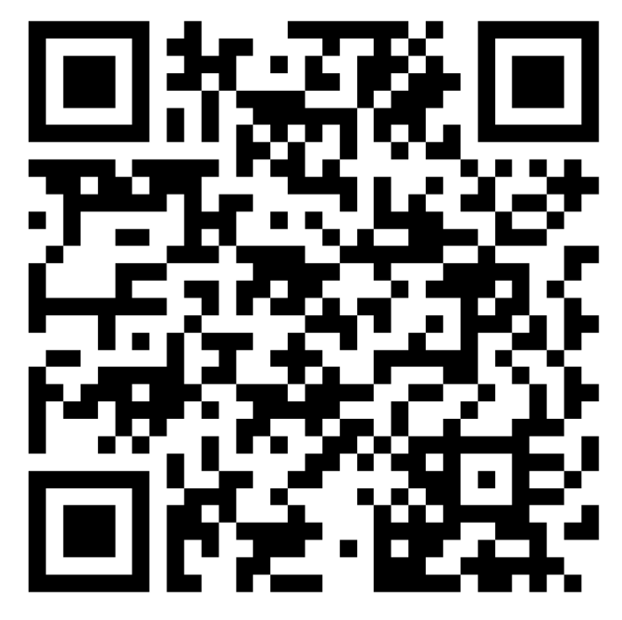
⚡ THINK DIFFERENT. BUILD BOLD.
Your problem statement.
Your research.
Your solution.
ARE YOU READY TO IDEATE?
📩 student.research@kct.ac.in
📱 8925226944 | 95971 11731
Instagram: @research.at.kct

